My Little Dreamer: A personality quiz to help you nurture your child’s interests.

Choose the answer that best fits your child.

1. When your child talks about an idea he/she has, it is:
a. A big picture idea, wonderfully abstract
b. Full of an amazing amount of details
c. A novel idea, visionary
d. Usually focused on helping people in need

2. Which activity would your child love to do the most?
a. Create a new recipe in the kitchen
b. Eat at his/her favorite restaurant
c. Try a new cuisine he/she has never had before
d. Any of the above, but with close friends

3. Which of the following best fits your child:
a. Feels emotions in a big way
b. Thinks through things that upset him/her, maybe makes lists of pros and cons
c. Views failures as a chance to learn
d. Able to put his/her own emotions aside to comfort others

4. When you ask your child to clean up his/her room and you walk in 10 minutes later, you will find that he/she has:
a. Picked up a few things, but is now involved in something creative
b. Cleaned up and has also organized something
c. Cleaned up and has also changed around how something in the room was set up
d. Cleaned up while listening to loud music

5. Which of the following is most true of your child?
a. Outgoing or more introverted but paves his/her own path and is friends with many types of people
b. Often the leader of his/her group of friends
c. Either introverted with a few very close friends or very friendly with everyone, but needs time on his/her own as well
d. Very extroverted and is a sounding board for most of his/her friends

6. Which of the following is true of their sense of justice?
a. Rules were made to be broken
b. Rules are important and keep society civilized and organized
c. Rules are important, but in some cases basic human rights can trump rules, which can be flawed
d. Rules are important, but one must trust one’s own instincts as well

7. Your child is doing a project for class. While everyone would help with each part, which of the following tasks would he/she most enjoy doing for the group?
a. Creating the presentation materials
b. Finding facts to support the group’s ideas
c. Coming up with the overall theme of the presentation and the main point
d. Presenting the project to the class

8. Your child is doing something that frustrates him/her and is very challenging. He/she...
a. May get upset, but then has a breakthrough and gets the task done
b. Puts his/her head down and works hard until it's done
c. Is extremely persistent and accomplishes things you thought would be impossible
d. All of the above

9. It’s a snow day! What would your child most likely do?
a. Spend all day creating snow sculptures
b. Watch the discovery channel and cozy up with a book
c. Go outside, find the biggest hill and go sledding!
d. Have fun with his/her neighborhood friends playing in the snow

10. What is your child's favorite school subject?
a. Art and/or music
b. History and/or English
c. Math and/or computer science
d. Science and/or psychology

Artist (Mostly A’s)
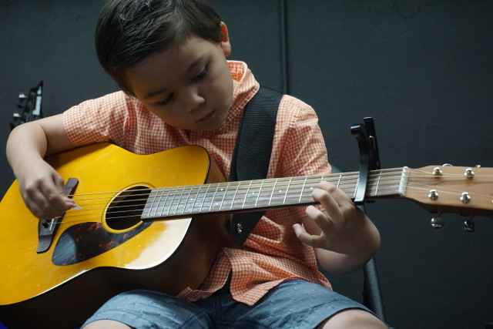
NYC Guitar School/Flickr

Your child’s dreamer traits are creativity, uniqueness and expressiveness. Artists have active imaginations that they express in unique ways. They may be more emotional, but use those emotions as energy in their creations. Your child wants to bring beauty and uniqueness into this world. A child may express this creativity and uniqueness through any career that allows him/her to create — for example, a musician, dancer, painter, chef, journalist or author.

You can inspire your young artist by taking him/her on a nature walk and encouraging the use of senses to fully experience the world. Start by focusing on what you can hear; listen to the birds singing and the wind through the leaves. Then, focus on what you can see — for example, the colors of leaves, patterns in water or grass and variations in light. Finally, ask your child to notice how things feel, such as the texture of tree bark or the softness of a fern. Research has shown that spending time outside increases creativity.

Professional (Mostly B's)
Image: Jerry Griffis/Flickr

Your child’s dreamer traits are conscientiousness, organization and responsibility. He/she is detail oriented, observant and careful. Children who have these traits are also usually very well regulated, get along well with others, and have a good sense of responsibility. Thus, they work well in groups and may often be leaders. They care about the state of the world and want to work hard to make it a better place. Your child may enjoy a career in business, law, engineering or science.

To cultivate your young professional and set him/her up for success, help him/her start and execute a project. It may be cleaning up a local park and organizing the neighborhood children to help, building and setting up a lemonade stand on the day your neighborhood has a garage sale, or helping with a holiday toy drive. These kinds of activities help to nurture your child’s sense of leadership and responsibility — skills he/she will use throughout life.

Innovator (Mostly C's)
Image: IU Kokomo/Flickr

Your child's dreamer traits are openness, creativity and intelligence. He/she is most likely open to new ideas, trying new foods or going to new places. He/she is highly intellectually curious and seeks out answers to many questions. Innovators are driven to come up with new and better ideas to help people change the world. They are not afraid of failure and are willing to take risks and try, try, try again. When they grow up, they will be leaders in any career they chose, but may be most drawn to science, technology and architecture.

Nurture your young innovator by reading with him/her and encouraging him/her to read. Reading about worlds with different physical rules and unexpected realities encourages innovation and creative problem solving. Reading with your child, perhaps reading the same book and talking about it, or taking turns reading chapters instills a love of reading that will last a lifetime.

Humanitarian (Mostly D's)
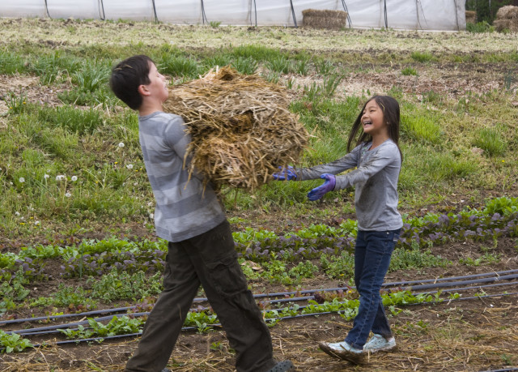
Cultivate Kansas City/Flickr

Your child's dreamer traits are agreeableness, caring and intelligence. He/she is empathetic and able to understand other people's perspectives. Humanitarians usually love animals and are nurturing to younger siblings. They have a natural insight into how to make someone feel better. If your child is a healer, then he/she might become a doctor, social worker, nurse, teacher, veterinarian or work for a non-profit. Whatever your humanitarian decides to do, it will definitely be something that will allow him/her to connect with and help others.

To nourish your young healer, get him/her involved in volunteering and giving back at a young age. Depending on other activities, it could be something you do once a year (like the soup kitchen on Thanksgiving) or every summer (like helping at the local animal shelter). Volunteering not only benefits the recipients, but also the volunteer. Some of the benefits of volunteering include enhancing positive well-being and potentially even higher grades in school.

Dreamers wanted! Join former boy-genius Frank (George Clooney), optimistic, science-minded teen Casey (Britt Robertson), mysterious Athena (Raffey Cassidy) and the brilliant David Nix (Hugh Laurie) in a world of pure Disney imagination and adventure. Tomorrowland transports you to an inspiring and magical place where if you can dream it, you can do it. Available on Blu-ray™, Digital HD & Disney Movies Anywhere October 13.

For more information on Tomorrowland, you can visit their website and follow them on Facebook and Google+.

